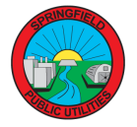
ATTENTION SPRINGFIELD PUBLIC UTILITIES RESIDENTIAL CUSTOMERS:
______________________________________________
- All rebate requests can be applied for through the online portal here: https://energyinsight.p3.enertrek.com/

- For any questions, please call or email:

Doug Eli
Deli@frontierenergy.com
(763) 222-3039

Thank you!
Springfield Public Utilities
2 East Central Street | 507-723-3500

